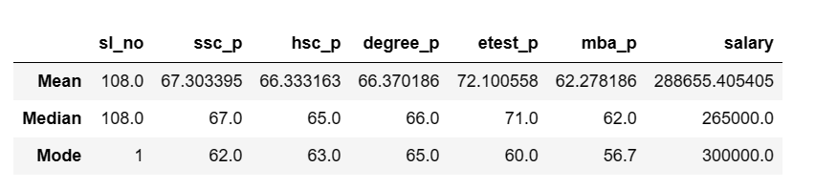

This is MBA college students data set.

While checking central tendency of this data we can conclude below

10th mark

1. Average 10 mark of these students is 67%
2. Median value of 10th mark of these students is 67% both looks same so no outliers in 10th mark
3. Mode of this 10th mark is 62 ie many people scored 62% marks in their 10th standard.

12th Mark

1. Average 12th mark of these students is 66%
2. Median value of 12th mark of this students is 65% both looks closer so very minor outlier is there in 12th mark
3. Mode of this 12th mark is 63 ie many people scored 63% marks in their 12th standard.

UG Degree Mark

1. Average UG mark of these students is 66%
2. Median value of UG mark of this students is 66% both looks same so outlier is not there in UG mark
3. Mode of this UG mark is 65 ie many people scored 65% marks in their US Mark.

Entrance test

1. Average entrance mark of these students is 72%
2. Median value of entrance mark of this students is 71% both looks same so very minor outlier is there in entrance mark
3. Mode of this entrance mark is 60 ie many people scored 60% marks in their entrance Mark.

MBA mark

1. Average MBA mark of these students is 62%
2. Median value of MBA mark of this students is 62% both looks same so no outlier is there in MBA mark
3. Mode of this MBA mark is 57 ie many people scored 57% marks in their MBA Mark.

salary

1. Average Salary of these students is 288685
2. Median salary of this students is 265000 minor outlier is there in salary
3. Mode of this salary is 300000 ie many people got 300000 salary